|  |  |  |
| --- | --- | --- |
|  |  | **Investigation of a Neuronal Network Application for a Learning Factory**  **Moritz Hoehnel**1**, Cheng Yee Low**2,*  1Faculty of Mechanics and Electronics,  Heilbronn University of Applied Sciences, Max-Planck-Str. 39, 74081 Heilbronn, Baden-Württemberg, Germany  2Faculty of Mechanical and Manufacturing Engineering,  University Tun Hussein Onn Malaysia, Parit Raja, 86400, MALAYSIA  *Corresponding Author Designation  DOI: https://doi.org/10.30880/rpmme.00.00.0000.00.0000  Received 00 Month 2022; Accepted 01 Month 2022; Available online 02 Month 2022  **Abstract:** Industrial production is undergoing significant changes due to advancements coming with Industry 4.0 in artificial intelligence and data processing, that may be difficult for local companies to envision. This report outlines an approach to implementing a neural network for data analysis, evaluates if it is viable for the factory simulation in the Innovationslab at Universiti Tun Hussein Onn Malaysia and provides a platform for knowledge transfer to domestic factories. Used is an online course provided by the Albstadt-Sigmaringen University about artificial intelligence. To transfer knowledge workshop materials have been created, a summary of an implementation has been put in the report and it was determined that hardware is missing at the factory simulation. For future work, missing hardware can be compensated by software solutions to apply the artificial network.  **Keywords:** Artificial Intelligence, Factory, Industry 4.0 |

1. **Introduction**

The fourth industrial revolution is accelerating, transforming industrial production through digitalization, robotics, and artificial intelligence [1]. The increasing impact of these developments can have positive effects on production costs. Industry 4.0 aims to connect workers and machines, using digitalization to collect and analyse production data. Advancing robot technologies support production steps that humans cannot handle, while artificial intelligence enhances the processing and analysis of production data. This project focuses on the artificial intelligence pillar by analysing the implementation of artificial data processing in a fully-operated robot factory.

The goal of artificial intelligence data analysing should be to know exactly where the workpiece is in the factory. This might sound trivial, but sensors do not cover every segment of production. A prediction model is therefore needed to determine the exact location of a workpiece.

The issue is that larger economy-leading companies have implemented important steps for the fourth industrial revolution, but smaller local companies are struggling to digitize and connect their workstations, resulting in isolated systems. Neuronal networks offer new data processing capabilities and efficiency gains. The traditional mentality of these companies hinders their transition to new technologies, so training courses on AI can help. The learning factory demonstrates that adopting manufacturing excellence for industry 4.0 is feasible.

This project focuses on transferring knowledge. The ministry of Ministry for Economy, Labour and Tourism of Baden-Wuerttemberg, Germany [2] outlines that technology and knowledge transfer can take many forms and be promoted in various ways. There are numerous virtual and physical transfer offerings available, including tutorials, trainings, continuing education, science-industry working groups, regional cluster initiatives and labs. One of the project outcomes should be a workshop like event that is hosted in the Innovationslab of the University. The expected participants are company managers. The course is required to be based on the Artificial Intelligence Factory Campus [3]. The workshop shall be created as extra material, which is kept in the Innovationslab.

The project report itself is dealing with two questions:

* How can a factory be analysed and controlled using a neuronal network?
* Is it possible to implement the artificial data analysation of the artificial intelligence factory campus on the factory simulation in the Innovationslab?

The first question will be answered by summarizing the artificial intelligence factory campus course. Dus it is expected that the controlling will be hardly possible. For the second question an analysation of the available hardware and software will be conducted.

1.1 Neuronal Networks

To understand the benefits of neuronal networks and how they work, this subchapter is giving a short overview about the topic. Information about this subchapter comes from [3] – [9].

Humans can easily obtain data, but the challenge for artificial neural networks is providing the computer with the capability to learn, extract patterns, and recognize them in new data. The goal is to analyse the human brain and create models that mimic it. The model network consists of small entities similar to neurons, acting as individual information storages. These entities, also shown in figure 1.1, are connected in a structure known as the neural network.

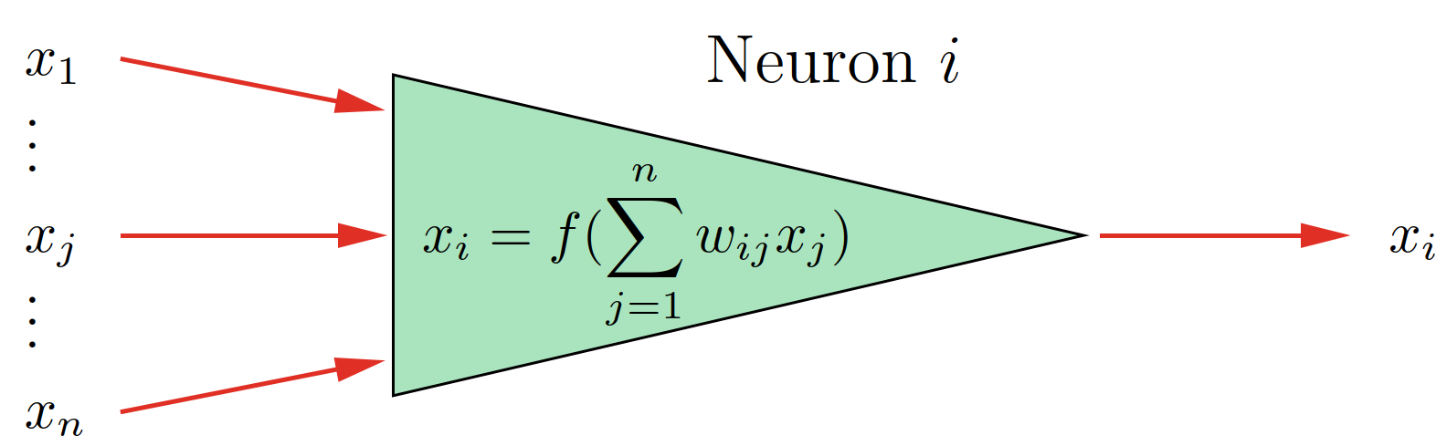

+

Weight 3

Weight 2

Weight 1

Input 3

Input 2

Input 1

Output

**Figure 1.1: Neuron [7]**

Each node has inputs and one output. Each of the inputs has a weight assigned. The weight gets multiplied with the corresponding input. The output is the result of an addition of the weighted inputs. The weights assigned to each input are calculated during training, with stronger connections formed between entities that communicate more frequently. Once clusters are established, tasks can be solved.

The issue of most common calculation is as they are not capable of predictions. It is also hard to deal with vast amounts of data as input. Neuronal networks make prediction based on the extracted attributes. Furthermore, they can improve calculation time.

1. **Materials and Methods**

The section called materials and methods provides all the essential details needed to achieve the study's results.

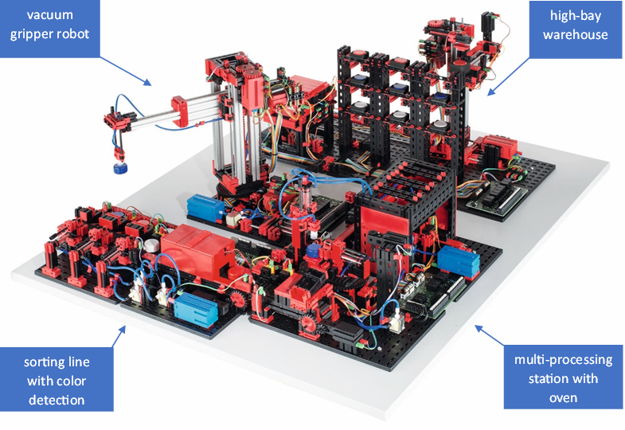Specifications and properties of state of the factory simulation will be described in this section. The factory simulation is a joint project of a number of students. This project is focusing on the analysis of the production site sensor data. To have data to analyse, the factory [10] needs to run first. This is why the assembly, wiring and implementation of the station control with a PLC is prerequisite. The next paragraph describes what the factory shown in figure 2.1 needs to be able to perform before the project start.

**Figure 2.1: Learning Factory [10]**

When an order is placed, the transport arm of the high-bay warehouse (HBW) moves to retrieve the ordered workpiece and places it in the input/output station. From there, it is taken to the vacuum suction pad's pick-up position. The vacuum gripper robot (VGR) then picks up the workpiece from the HBW station and places it onto the furnace's slide where it undergoes firing. Next, the transport carriage with the vacuum suction pad transports the workpiece to the milling processing machine where it is placed on a rotary table. After the milling process, the workpiece is pushed onto the conveyor belt pneumatically. As the workpiece moves along the conveyor belt, it passes through a colour recognition system. Depending on the colour detected, the workpiece is pneumatically pushed onto the corresponding material chute.

Furthermore, the AI campus learning factory [3] will serve as model.

1. **Results and Discussion**

The results will be presented in order of the questions. The first question was to find how the AI-Learning Factory course analyses and controls the factory using a neuronal network. The following graph shows the configuration.

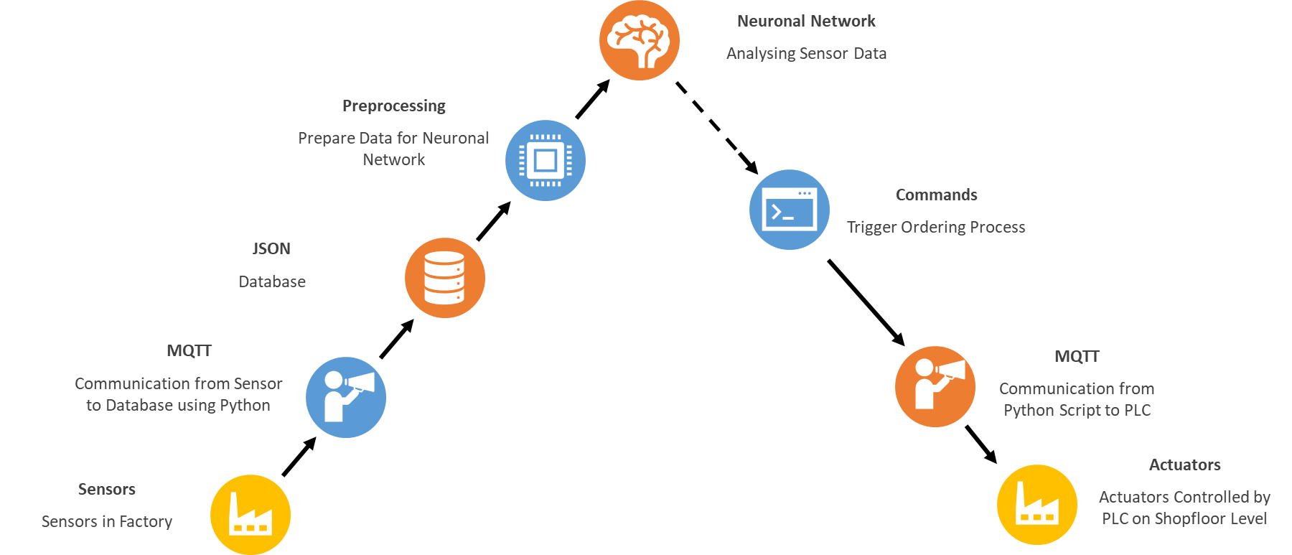

**Figure 3.1: Overview Implementation**

The graphic starts at factory shopfloor level. Installed sensors take values. Senor types include switches, light barriers and colour detection. A txt controller collects all the data. A python script is executed to start a communication to the txt controller using the MQTT protocol. The same python script then writes the data into a JSON database. From there, a further python script is collecting the data and carries out the preprocessing. This includes steps of sorting information by time and deleting unnecessary data as well as double information.

The neuronal network takes the prepared information. Its goal is to find out the exact location of the workpiece. This is important as sensors do not cover the hole factoring process. For the purpose a convolutional neuronal network is used. As the factory can have 13 states, 13 input neurons are needed. For the implementation a 14th neuron has been added that feeds the model with random values. Its purpose is to avoid overfitting the model. Furthermore, the network has one hidden layer with 10 neurons and the output layer has also 10 neurons. The result of the neuronal network is shown in the console of a PC on which the python script is running. The user can then accordingly trigger an ordering process in the command window.

**Figure 3.2: High Bay Warehouse [3]**

During ordering a colour of workpiece can be chosen. The script also knows where to find a fitting piece in the high bay warehouse shown in figure 3.2. The ordering process will trigger the workpiece gathering and the fabrication. This is done by communicating to the factory level PLC via MQTT. The communication is coordinated by a further python script. The PLC is controlling each actuator accordingly.

The second question is to evaluate if it is possible to implement the artificial data analysation of the artificial intelligence factory campus on the factory simulation in the Innovationslab. The figure is showing the ideal condition of the factory for the use of the Artificial intelligence factory course. It identifies the required hardware and missing software. Figure 3.3 is highlighting the parts that are not yet present in the learning factory of the Innovation-Lab.

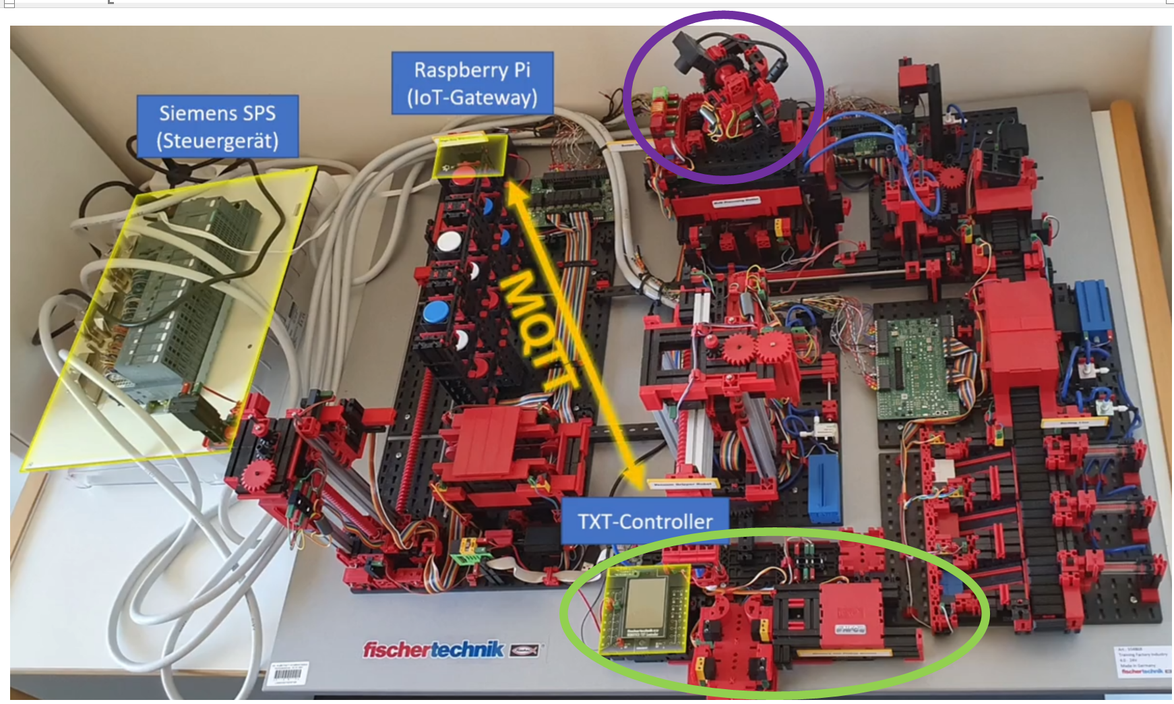

**Figure 3.3: Overview of Hardware [11]**

The purple highlighted parts represent a combined sensor station located on top of the oven. The main sensor of the station is a 360° camera used for web-based remote control. It is not integrated into the factory's control software, but rather allows remote viewing. Other sensors in the station measure brightness, temperature, humidity, and air quality, providing data for monitoring the factory and ensuring that the production process stays within limits.

The green circle highlights the delivery station, which is currently not present in the Innovationslab. It is used for incoming and outgoing goods and consists of various elements. At the end of the production process, the gripper places the workpiece in the delivery space, activating a light barrier. This information is collected by the controlling script and is processed along with other station’s data for analysis using the neural network. Missing information is seen as a production interruption and a potential software hang-up.

The gripper then places the workpiece onto a colour sensor to detect its colour, which is stored in the software. Customers can select their desired colour during ordering and the software can match the product accordingly. In the final step of the delivery station, an NFC reader and writer tags the workpiece with production information. While this step simulates real-world factories, the NFC chip of the workpiece is not read again. This means it is not necessary for the neural network. The delivery station is connected to the Fischertechnik txt controller, which collects all sensor information and sends it to the IoT-Gateway via MQTT. The chip and software used are not specified, making it difficult to replicate this element. The IoT-Gateway receives data from the txt controller, which serves two purposes. It controls the ordering process using a Python script introduced in the course.

Due to missing hardware, the Albstadt-Sigmaringen university's course cannot be directly applied to the learning factory in the Innovationslab.

1. **Conclusion**

This chapter concludes the AI-Learning factory project and provides recommendations. Like described in the results the course cannot be directly applied to the learning factory in the Innovationslab. To solve this problem either the missing hardware needs to be acquired or a new set of software files needs to be created that compensate for the lack of hardware. As hardware acquiring is expensive, future projects can focus on creating new software that orientate on the architecture described in this report. The main objectives for future projects would be to collect the sensor data, create a new way of data preparation and a new neuronal network. As for the data collection I would recommend to use the PLC, which also has access to all sensor values. Then a communication script can use the UPCUA protocol to fetch sensor information. For the following steps, the python scripts need to be adjusted accordingly to the set of data provided by the PLC.

This paragraph determines the success of the project. The AI-Lernfabrik course was attended and tasks were completed, resulting in the creation of a workshop manual and task solutions. The working principle of the factory was summarized to highlight the key learnings. Finally, the implementation of the Innovationslab factory simulation has been evaluated as not possible with the current hardware and software.

**Acknowledgement**

I would like to express my gratitude to Dr. Low Cheng Yee for consistently supporting me. Additionally, I would like to thank all the individuals at UTHM-Frauenhofer IEM Innovation Lab. Collaborating with such helpful individuals was truly a good opportunity. Being a part of the project learning factory was an enriching experience, and I would particularly like to acknowledge Mattis Tom Ritter for the good cooperation.

**References**

|  |  |
| --- | --- |
|  |  |
| [1] | Mercedes Benz Group (2023). Industry 4.0 and the networked factory. Retrieved on May 20, 2023, from https://group.mercedes-benz.com |
| [2] | Ministry for Economy, Labour and Tourism (2023). Technology and Knowledge Transfer. Retrieved on June 30, 2023, from https://www.wirtschaft-digital-bw.de |
| [3] | KI Campus (2022). Lernfabrik 4.0 – Steuerung, Monitoring und NN-Modell. Retrieved on June 25, 2023, from https://learn.ki-campus.org |
| [4] | Luger G. F. & Stubblefield W. A.. Artificial intelligence. 2nd Ed. Albuquerque. Benjamin/Cummings Pub. Co.. 1993 |
| [5] | Hebb, D. O.. The Organization of Behavior. 1st Ed. New York. Psychology Press. 2002 |
| [6] | Picton, P.. Introduction to Neural Networks. 1st Ed. London. Red Globe Press London. 1994 |
| [7] | Ertel, W.. Grundkurs Künstliche Inelligenz. 5th Ed. Weingarten. Springer. 2021 |
| [8] | Grum, M..Construction of a Concept of Neuronal Modeling. 1st Ed. Berlin. Springer. 2022 |
| [9] | Sonnet, D.. Neuronale Netzwerke kompakt. 1st Ed. Hamburg. Springer Vieweg. 2022 |
| [10] | Fischertechnik (2023). Lernfabrik 4.0. Retrieved on May 5, 2023, from https://www.fischertechnik.de |
| [11] | Klein, M. (2022). Osteraktion 12 Weiterbildung. Retrieved on May 26, 2023, from https://www.hs-albsig.de |